Sixty Four Pixels
For full build instructions and step-by-step guides, please check out https://github.com/hotchk155/AVRGame/wiki

Your kit includes:

- Printed circuit board
- IC1, IC2 - TPIC6B595N power logic shift register
- IC3 - ATMEGA328P-PU microcontroller
- R1-R8 - 220R resistor (red-red-black code)
- R9 - 1K resistor (brown-black-red code)
- C1, C2 - 33pF ceramic capacitor (33 code)
- C3, C4, C5, C6 - 100nF cap (104 code)
- X1 - 16MHz crystal
- PWR - Miniature slide switch
- LED1 - 3MM standard LED. The longer leg is the anode (+ terminal)
- SPK1 - 5V piezo transducer. The anode (+ terminal) is identified on the label. Remove the label after fitting.
- A,B,C,D,RESET - 6mm tactile switch
- SERIAL - 6 pin male header 0.1" pitch. This is intended to fit a standard FTDI USB-to-TTL serial programming cable (not supplied)
- DISP1 - 8x8 red/green LED matrix. Pin 1 is indicated with a coloured label. Please ensure correct fitting to the board – it is very difficult to remove if soldered incorrectly!
- IC sockets (20 and 28 pin). Line up the notch on the end with the image on the board
- 3xAAA battery box with flying leads. Trim leads to required length. Please see web site for advice
- Double sided foam pads to fix battery box to reverse of PCB. These need to be cut to fit. Please see web site for advice.

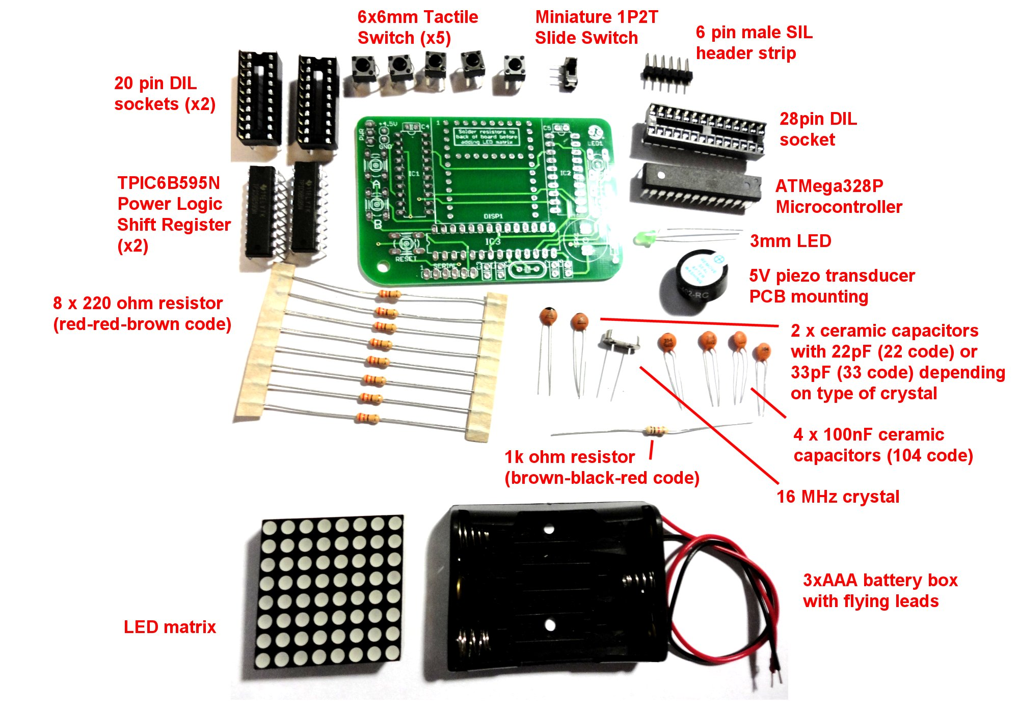
To contact me, please email sixtyfourpixels@gmail.com

Sixty Four Pixels
For full build instructions and step-by-step guides, please check out https://github.com/hotchk155/AVRGame/wiki

Your kit includes:

- Printed circuit board
- IC1, IC2 - TPIC6B595N power logic shift register
- IC3 - ATMEGA328P-PU microcontroller
- R1-R8 - 220R resistor (red-red-black code)
- R9 - 1K resistor (brown-black-red code)
- C1, C2 - 33pF ceramic capacitor (33 code)
- C3, C4, C5, C6 - 100nF cap (104 code)
- X1 - 16MHz crystal
- PWR - Miniature slide switch
- LED1 - 3MM standard LED. The longer leg is the anode (+ terminal)
- SPK1 - 5V piezo transducer. The anode (+ terminal) is identified on the label. Remove the label after fitting.
- A,B,C,D,RESET - 6mm tactile switch
- SERIAL - 6 pin male header 0.1" pitch. This is intended to fit a standard FTDI USB-to-TTL serial programming cable (not supplied)
- DISP1 - 8x8 red/green LED matrix. Pin 1 is indicated with a coloured label. Please ensure correct fitting to the board – it is very difficult to remove if soldered incorrectly!
- IC sockets (20 and 28 pin). Line up the notch on the end with the image on the board
- 3xAAA battery box with flying leads. Trim leads to required length. Please see web site for advice
- Double sided foam pads to fix battery box to reverse of PCB. These need to be cut to fit. Please see web site for advice.

To contact me, please email sixtyfourpixels@gmail.com

